**1.** **Create web pages using Basic HTML Tags, Table, List, Image, and Frame Tags:**

<html>

<body bgcolor="darkorange">

<imgsrc="C:\Users\hp\Desktop\html\images\header.jpg" style="height: 100%" width="100%">

</body>

</html>

<html>

<body>

<imgsrc="C:\Users\hp\Desktop\html\images\aditya.jpg" style="height: 100%" width="100%">

</body>

</html>

<html>

<body bgcolor="darkorange">

<imgsrc="C:\Users\hp\Desktop\mydocc\images\sports.jpg" style="height: 100%" width="100%">

</body>

</html>

<html>

<body bgcolor="skyblue">

<font size="5" color="green">

<a href="tttt.html" target="tttt">www.aec.edu.in</a><br/>

<a href="ssssss.html" target="ssssss">www.careers360.com</a><br/>

<a href="kkkkkk.html" target="kkkkkk">info.aec.edu.in/aec/default.aspx></a>

</font>

</body>

</html>

<frameset cols="30%,*">

<frame name="fr1" src="link.html">

<frameset rows="25%,45%,*">

<frame name="first" src="tttt.html">

<frame name="second" src="ssssss.html">

<frame name="third" src="kkkkkk.html">

</frameset></frameset>

**Output:**



**2.1). Create a “Login form”**

**PROGRAM:**

<!DOCTYPE html>

<html>

<head>

<title>Login Form</title>

</head>

<body style=" background-color: violet">

<h2 style="text-align:center;color: brown;font-size: 50px;">STUDENT LOGIN FORM</h2>

<form style="text-align:center;font-size: 25px; ">

USERNAME:

<input type="text" name="USERNAME" value="chandini" >(max of 30 characters a-z and A-Z)<br><br>

PASSWORD:

<input type="password" name="PASSWORD">(max of 30 characters a-z and A-Z)<br><br>

<input type="submit" value="SUBMIT">

<input type="Reset" value="RESET">

</form>

</body>

</html>

**OUTPUT:**

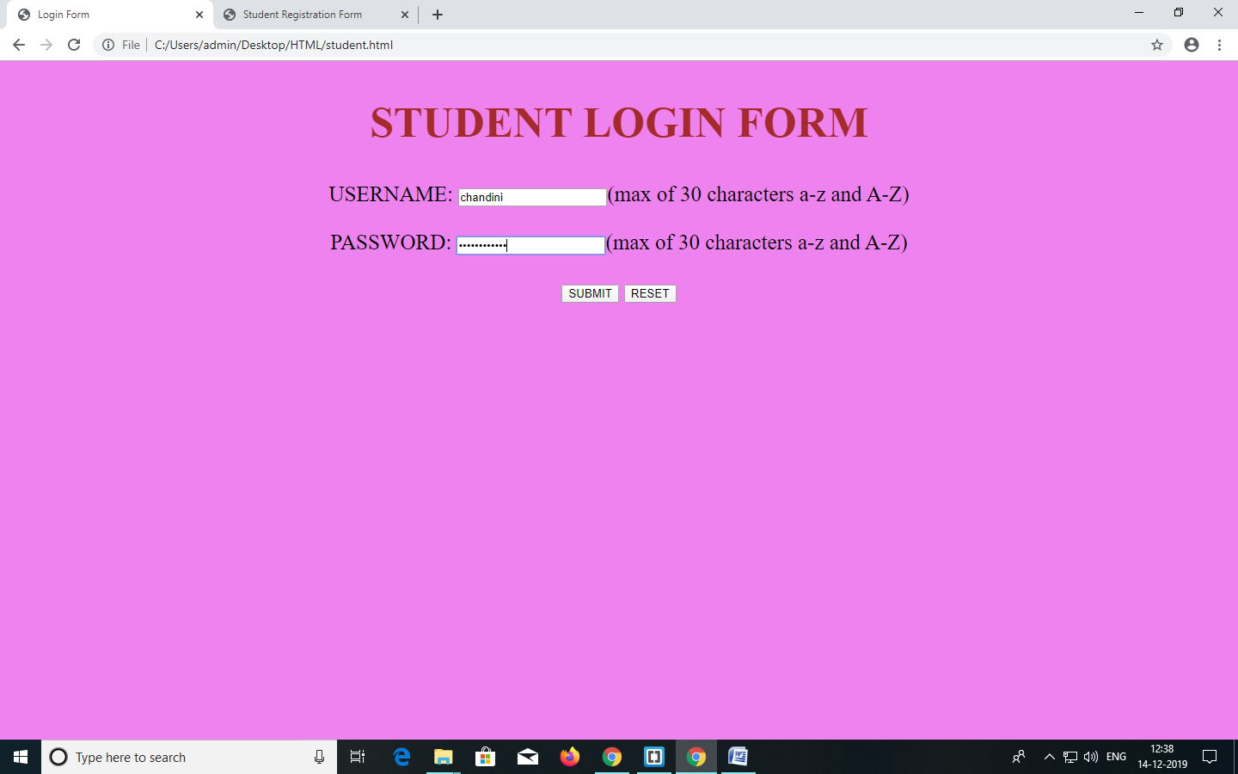

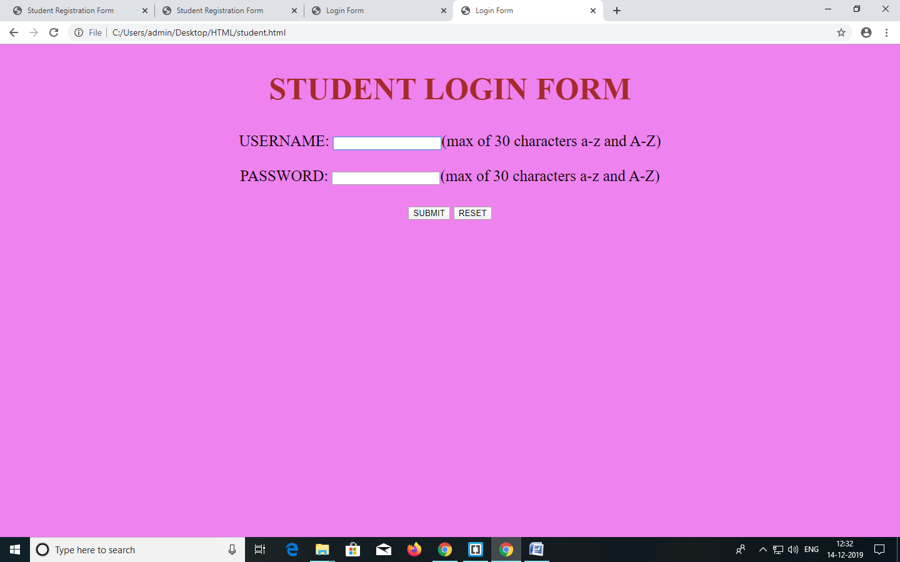

**RESULT:** Login form created successfully.

**2.2). Create a “registration form”**

**PROGRAM:**

<html>

<head>

<title>Student Registration Form</title>

</head>

<body bgcolor="violet">

<h1 align="center">STUDENT REGISTRATION FORM</h1>

<table bgcolor="orangepink" align="center" cellpadding = "10">

<!----- First Name ---------------------------------------------------------->

<tr>

<td>FIRST NAME</td>

<td><input type="text" name="First_Name" maxlength="30"/>

(max 30 characters a-z and A-Z)

</td>

</tr>

<!----- Last Name ---------------------------------------------------------->

<tr>

<td>LAST NAME</td>

<td><input type="text" name="Last_Name" maxlength="30"/>

(max 30 characters a-z and A-Z)

</td>

</tr>

<tr>

<td>password:</td>

<td><input type="password" name="pwd" maxlength="30"></td>

</tr>

<!----- Date Of Birth -------------------------------------------------------->

<tr>

<td>DATE OF BIRTH</td>

<td>

<select name="Birthday_day" id="Birthday_Day">

<option value="-1">Day:</option>

<option value="1">1</option>

<option value="2">2</option>

<option value="3">3</option>

<option value="4">4</option>

<option value="5">5</option>

<option value="6">6</option>

<option value="7">7</option>

<option value="8">8</option>

<option value="9">9</option>

<option value="10">10</option>

<option value="11">11</option>

<option value="12">12</option>

<option value="13">13</option>

<option value="14">14</option>

<option value="15">15</option>

<option value="16">16</option>

<option value="17">17</option>

<option value="18">18</option>

<option value="19">19</option>

<option value="20">20</option>

<option value="21">21</option>

<option value="22">22</option>

<option value="23">23</option>

<option value="24">24</option>

<option value="25">25</option>

<option value="26">26</option>

<option value="27">27</option>

<option value="28">28</option>

<option value="29">29</option>

<option value="30">30</option>

<option value="31">31</option>

</select>

<select id="Birthday_Month" name="Birthday_Month">

<option value="-1">Month:</option>

<option value="January">Jan</option>

<option value="February">Feb</option>

<option value="March">Mar</option>

<option value="April">Apr</option>

<option value="May">May</option>

<option value="June">Jun</option>

<option value="July">Jul</option>

<option value="August">Aug</option>

<option value="September">Sep</option>

<option value="October">Oct</option>

<option value="November">Nov</option>

<option value="December">Dec</option>

</select>

<select name="Birthday_Year" id="Birthday_Year">

<option value="-1">Year:</option>

<option value="2012">2012</option>

<option value="2011">2011</option>

<option value="2010">2010</option>

<option value="2009">2009</option>

<option value="2008">2008</option>

<option value="2007">2007</option>

<option value="2006">2006</option>

<option value="2005">2005</option>

<option value="2004">2004</option>

<option value="2003">2003</option>

<option value="2002">2002</option>

<option value="2001">2001</option>

<option value="2000">2000</option>

<option value="1999">1999</option>

<option value="1998">1998</option>

<option value="1997">1997</option>

<option value="1996">1996</option>

<option value="1995">1995</option>

<option value="1994">1994</option>

<option value="1993">1993</option>

<option value="1992">1992</option>

<option value="1991">1991</option>

<option value="1990">1990</option>

<option value="1989">1989</option>

<option value="1988">1988</option>

<option value="1987">1987</option>

<option value="1986">1986</option>

<option value="1985">1985</option>

<option value="1984">1984</option>

<option value="1983">1983</option>

<option value="1982">1982</option>

<option value="1981">1981</option>

<option value="1980">1980</option>

<option value="1980">1979</option>

<option value="1980">1978</option>

<option value="1980">1977</option>

<option value="1980">1976</option>

<option value="1980">1975</option>

<option value="1980">1974</option>

<option value="1980">1973</option>

<option value="1980">1972</option>

<option value="1980">1971</option>

<option value="1980">1970</option>

</select>

</td>

</tr>

<!----- Email Id ---------------------------------------------------------->

<tr>

<td>EMAIL ID</td>

<td><input type="text" name="Email_Id" maxlength="100" /></td>

</tr>

<!----- Mobile Number ---------------------------------------------------------->

<tr>

<td>MOBILE NUMBER</td>

<td>

<input type="text" name="Mobile_Number" maxlength="10" />(10 digit number)

</td>

</tr>

<!----- Gender ----------------------------------------------------------->

<tr>

<td>GENDER</td>

<td>

Male <input type="radio" name="Gender" value="Male" />

Female <input type="radio" name="Gender" value="Female" />

</td>

</tr>

<!----- Language --------------------------------------------------------->

<tr>

<td>LANGUAGE</td>

<td>

English <input type="radio" name="Language" value="English" />

Telugu <input type="radio" name="Language" value="Telugu" />

Hindi <input type="radio" name="Language" value="Hindi" />

Tamil <input type="radio" name="Language" value="Tamil" />

</td>

</tr>

<!----- Address ---------------------------------------------------------->

<tr>

<td>ADDRESS <br /><br /><br /></td>

<td><textarea name="Address" rows="4" cols="30"></textarea></td>

</tr>

<!----- Submit and Reset ------------------------------------------------->

<tr>

<td colspan="2" align="center">

<input type="submit" value="Submit">

<input type="reset" value="Reset">

</td>

</tr>

</table>

</body>

</html>

**OUTPUT:**

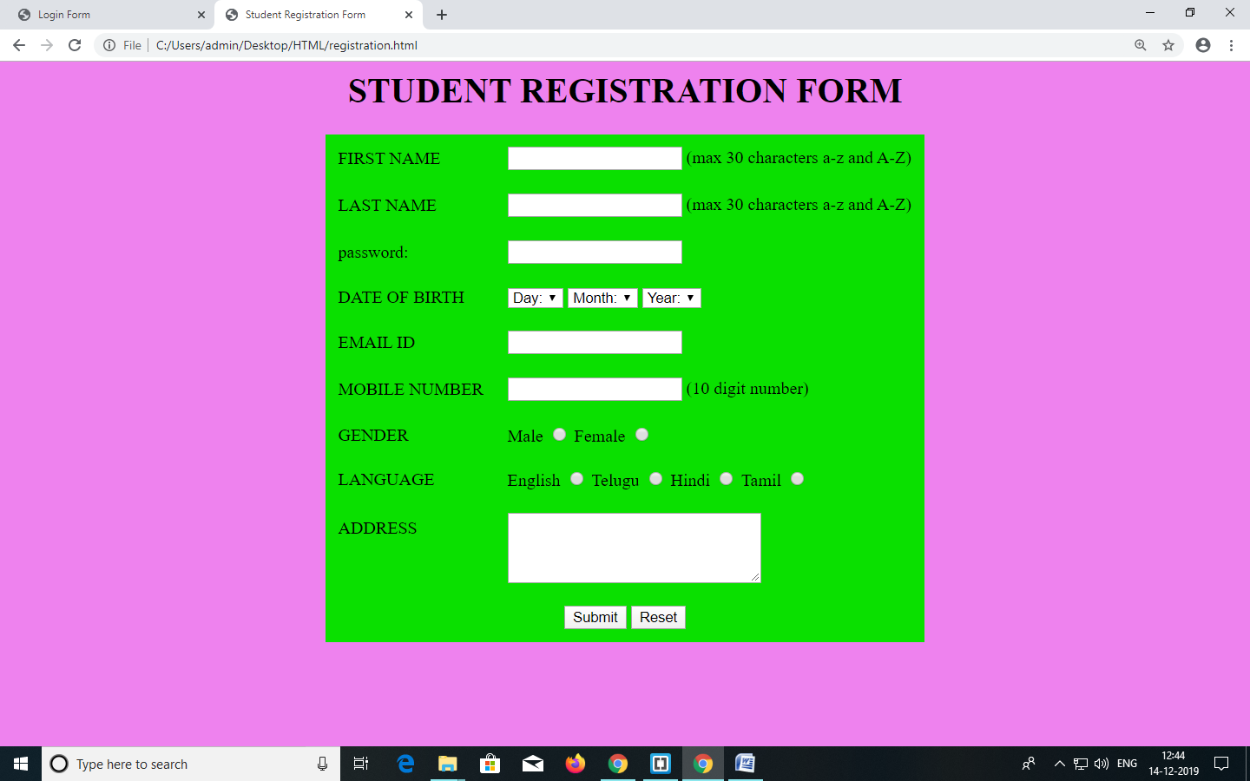

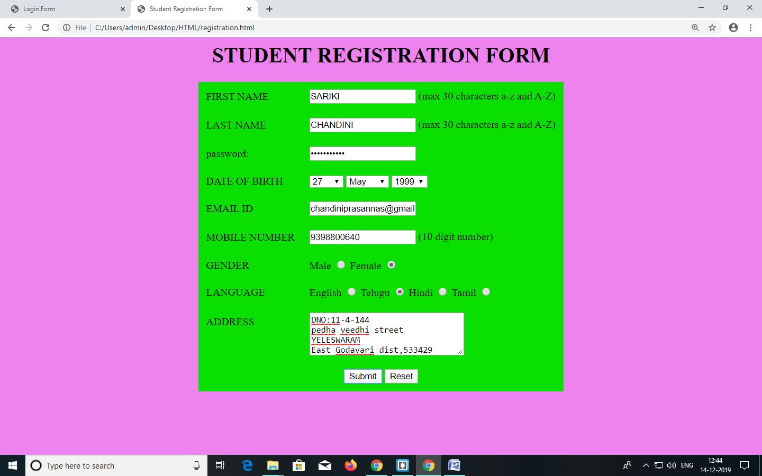

**RESULT:** Registration form created successfully.

**3.1.1)** **Use different font, styles: In the style definition you define how each selector should work (font, color etc). Then, in the body of your pages, you refer to these selectors to activate the styles.:-**

**Ext.css**

h1{

text-align: center;

background-color: gold;

font-style: italic;

font-size: 40px;

border-color: yellowgreen;

color: fuchsia;

font-family: cursive;

background-image: url(immm.jpg);

background-repeat: no-repeat;

}

p{

text-align: center;

background-color: aquamarine;

border-color: aqua;

font-size: 20px;

margin-bottom: inherit;

color: royalblue;

text-decoration: underline;

font-family: monospace;

font-style: oblique;

tab-size: 40px;

}

ul.a{

list-style-type: circle;

color:sandybrown;

font-size:20px;

}

.k{

border: 2px solid red;

color:teal;

font-size:30px;

}

**Extr.html:**

<html>

<head>

<link href="ext.css" rel="stylesheet">

</head>

<body style="background-color: aquamarine">

<h1>Welcome to WebTechnology</h1>

<p>Short for HyperText Markup Language, the authoring language used to create documents on the World Wide Web. HTML is similar to SGML, although it is not a strict subset. HTML defines the structure and layout of a Web document by using a variety of tags and attributes.Short for HyperText Markup Language, the authoring language used to create documents on the World Wide Web. HTML is similar to SGML, although it is not a strict subset. HTML defines the structure and layout of a Web document by using a variety of tags and attributes.Short for HyperText Markup Language, the authoring language used to create documents on the World Wide Web. HTML is similar to SGML, although it is not a strict subset. HTML defines the structure and layout of a Web document by using a variety of tags and attributes.Short for HyperText Markup Language, the authoring language used to create documents on the World Wide Web. HTML is similar to SGML, although it is not a strict subset. HTML defines the structure and layout of a Web document by using a variety of tags and attributes.Short for HyperText Markup Language, the authoring language used to create documents on the World Wide Web. HTML is similar to SGML, although it is not a strict subset. HTML defines the structure and layout of a Web document by using a variety of tags and attributes.Short for HyperText Markup Language, the authoring language used to create documents on the World Wide Web. HTML is similar to SGML, although it is not a strict subset</p><ul class="a">

<li>HTML defines the structure and layout of a Web document by using a variety of tags and attributes</li>

<li> Short for HyperText Markup Language, the authoring language used to create documents on the World Wide Web. </li>

<li>HTML is similar to SGML, although it is not a strict subset. HTML defines the structure and layout of a Web document</li>

</ul>

<table class="k";table cellpadding="8px";table frame="box";table rules="rows";table width="60px" height="40px";table rules="cols">

<tr>

<th>Group</th>

<th>Time</th>

</tr>

<tr>

<td>Women</td>

<td>10</td>

</tr>

<tr>

<td>Men</td>

<td>20</td>

</tr>

<tr>

<td>Men</td>

<td>30</td>

</tr>

<tr>

<td>women</td>

<td>50</td>

</tr>

</table>

</body>

</html>

**OUTPUT:**

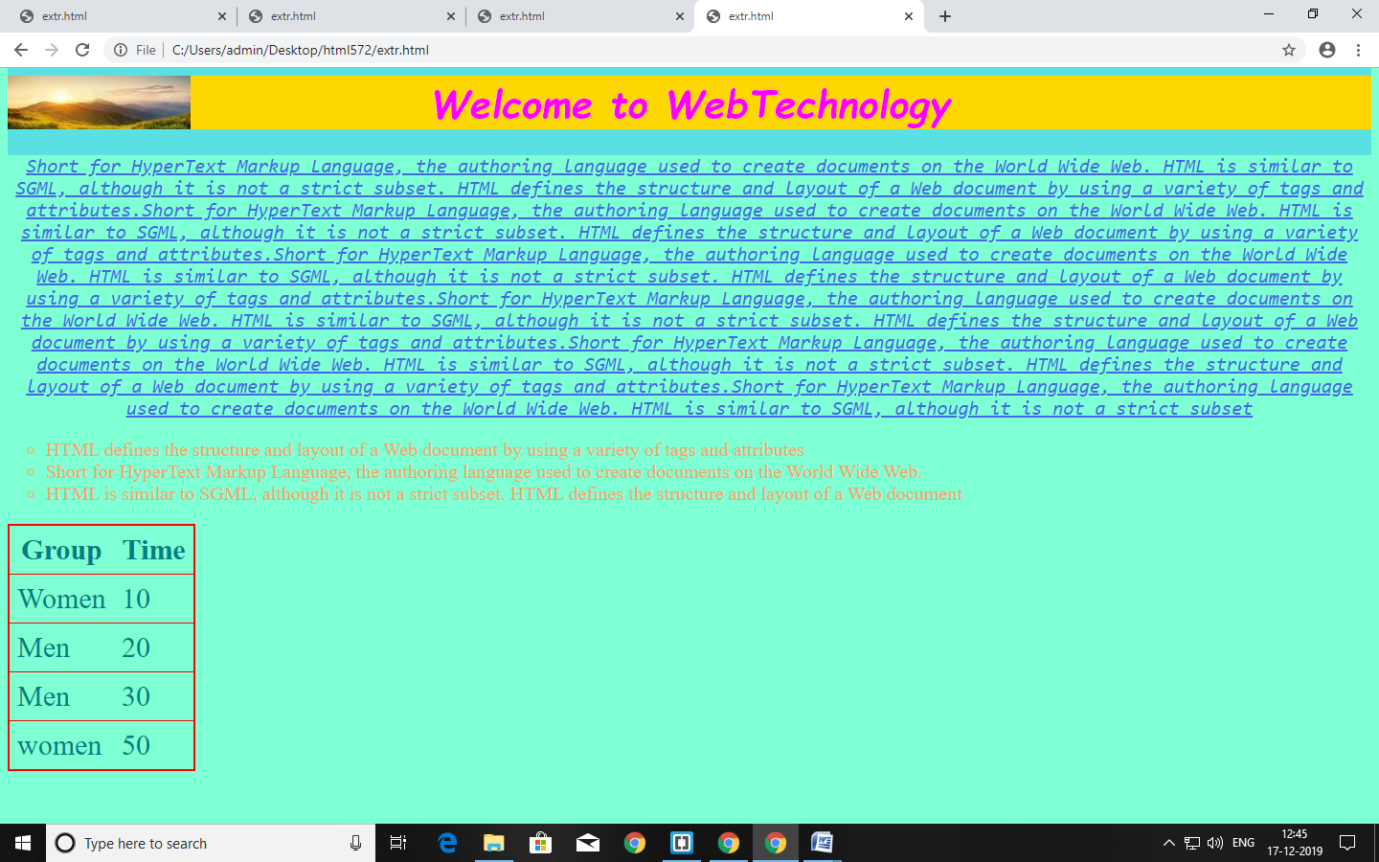

**3.1.2) Set a background image for the web page and control the repetition of the image with the background-repeat property.**

<html>

<head>

<title>My style</title>

<link href="f2.css" rel="stylesheet">

</head>

<body>

<h1>

good morning everyone

</h1>

<ul>

<li>hello</li>

<li>hi</li>

</ul>

</body>

<html>

**Css code:**

body{

background-image: url("cb.jpg");

background-repeat: no-repeat;

background-size:cover;

}

h1{

color:aquamarine;

font-size:100px;

}

ul{

color:hotpink;

background-color:yellow;

}

**OUTPUT:**

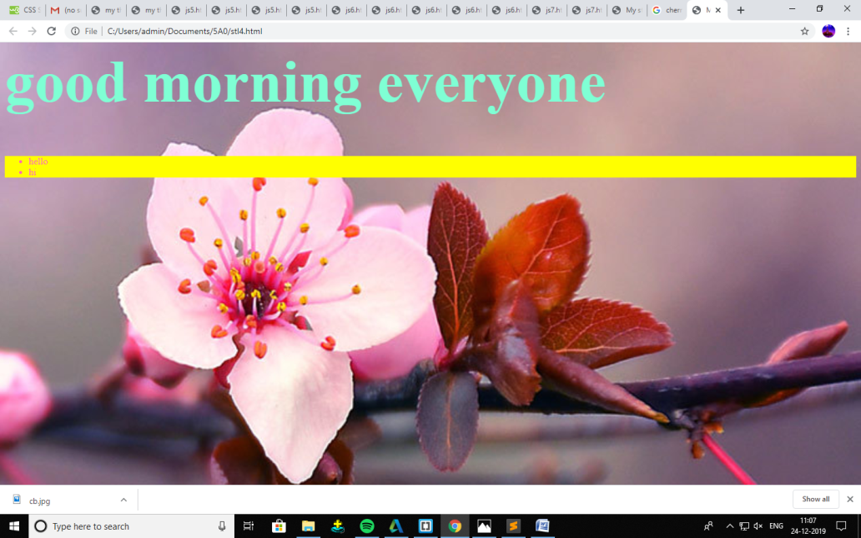

**\*3.2)** **JavaScript that takes a number from one text field in the range of 0-999 and display it in other text field in words.*/**

<html>

<head>

<title>NUMBERS</title>

</head>

<script language="javascript">

function convert_number_to_words(number){

hyphen='-';

conjunction='and';

separator=',';

dictionary={

0:'zero',1:'one',2:'two',3:'three',4:'four',5:'five',6:'six',7:'seven',8:'eight',9:'nine',10:'ten',11:'eleven',

12:'twelve',13:'thirteen',14:'fourteen',15:'fifteen',16:'sixteen',17:'seventeen',18:'eighteen',

19:'nineteen',20:'twenty',30:'thirty',40:'forty',50:'fifty',60:'sixty',70:'seventy',80:'eighty',

90:'ninety',100:'hundred'};

if(number<0||number>999)

{

alert("Enter a number which is in the range between 0 and 999");

return "";

}

switch(true)

{

case(number<21):

string=dictionary[number];

break;

case(number<100):

tens=parseInt(number/10)*10;

units=number%10;

string=dictionary[tens];

if(units){

string+=hyphen+dictionary[units];}

break;

case(number<1000):

hundreds=parseInt(number/100);

remainder=number%100;

string=dictionary[hundreds]+' '+dictionary[100];

if(remainder){

string+=" "+conjunction+" "+convert_number_to_words(remainder);}

break;

default:

break;

}

return string;

}

a=prompt("Enter a number");

num=parseInt(a);

document.write(convert_number_to_words(num));

</script>

</html>

**OUTPUT:**

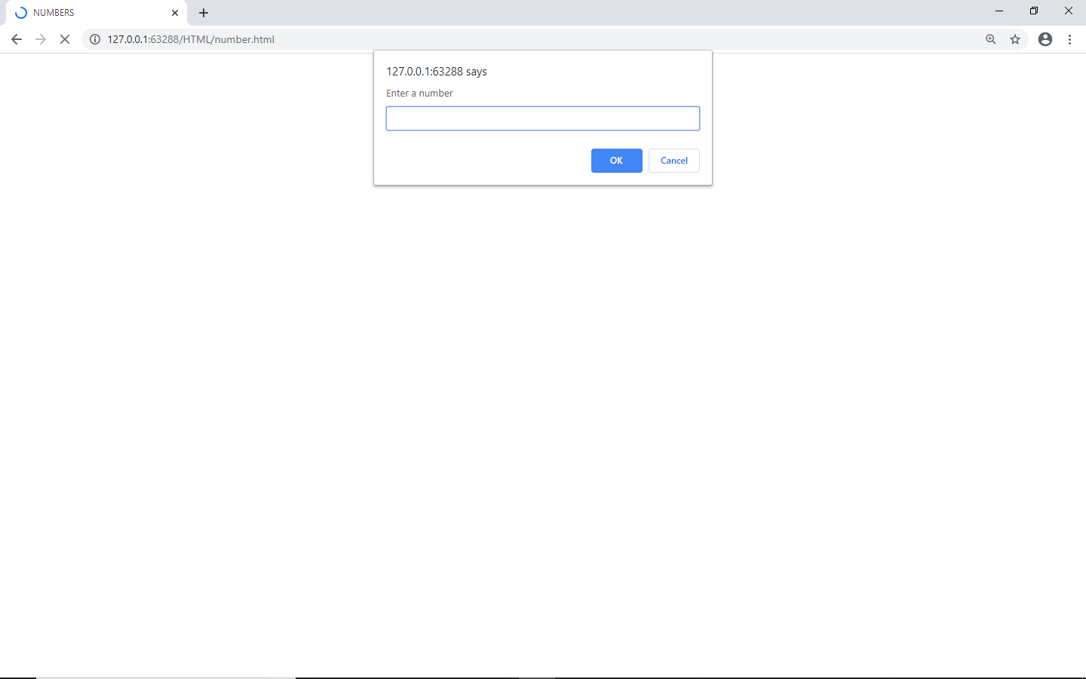

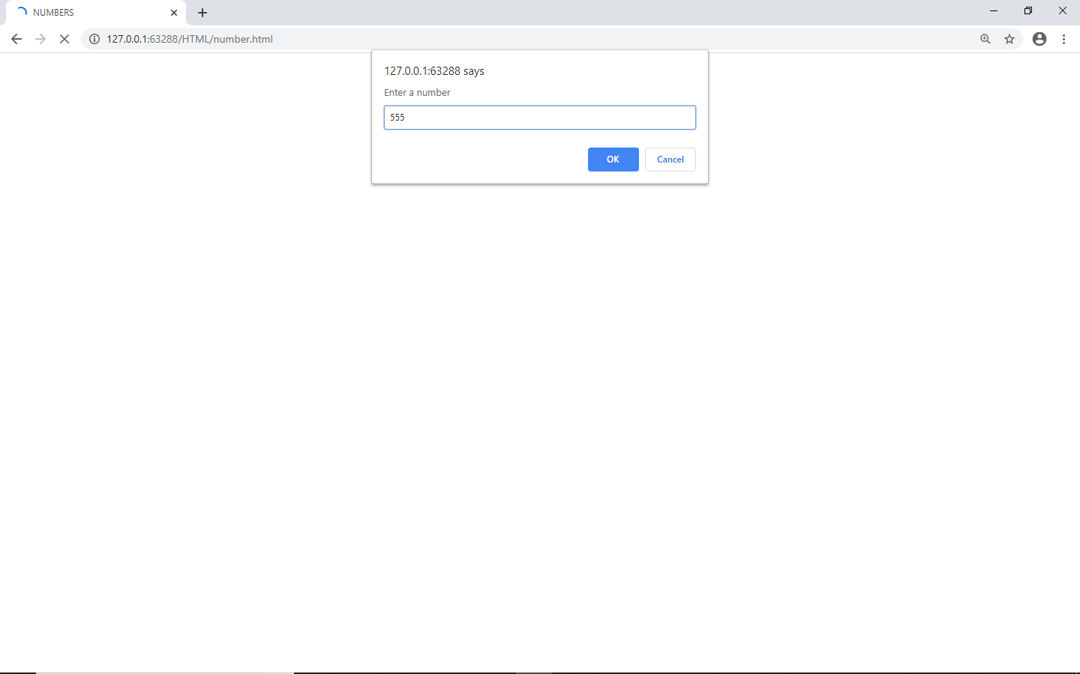

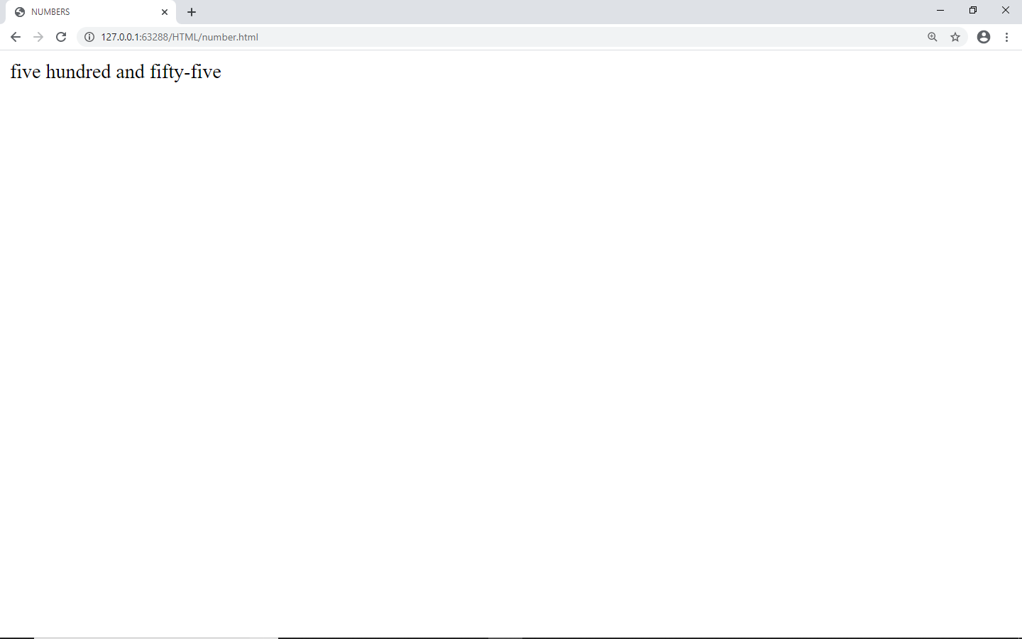

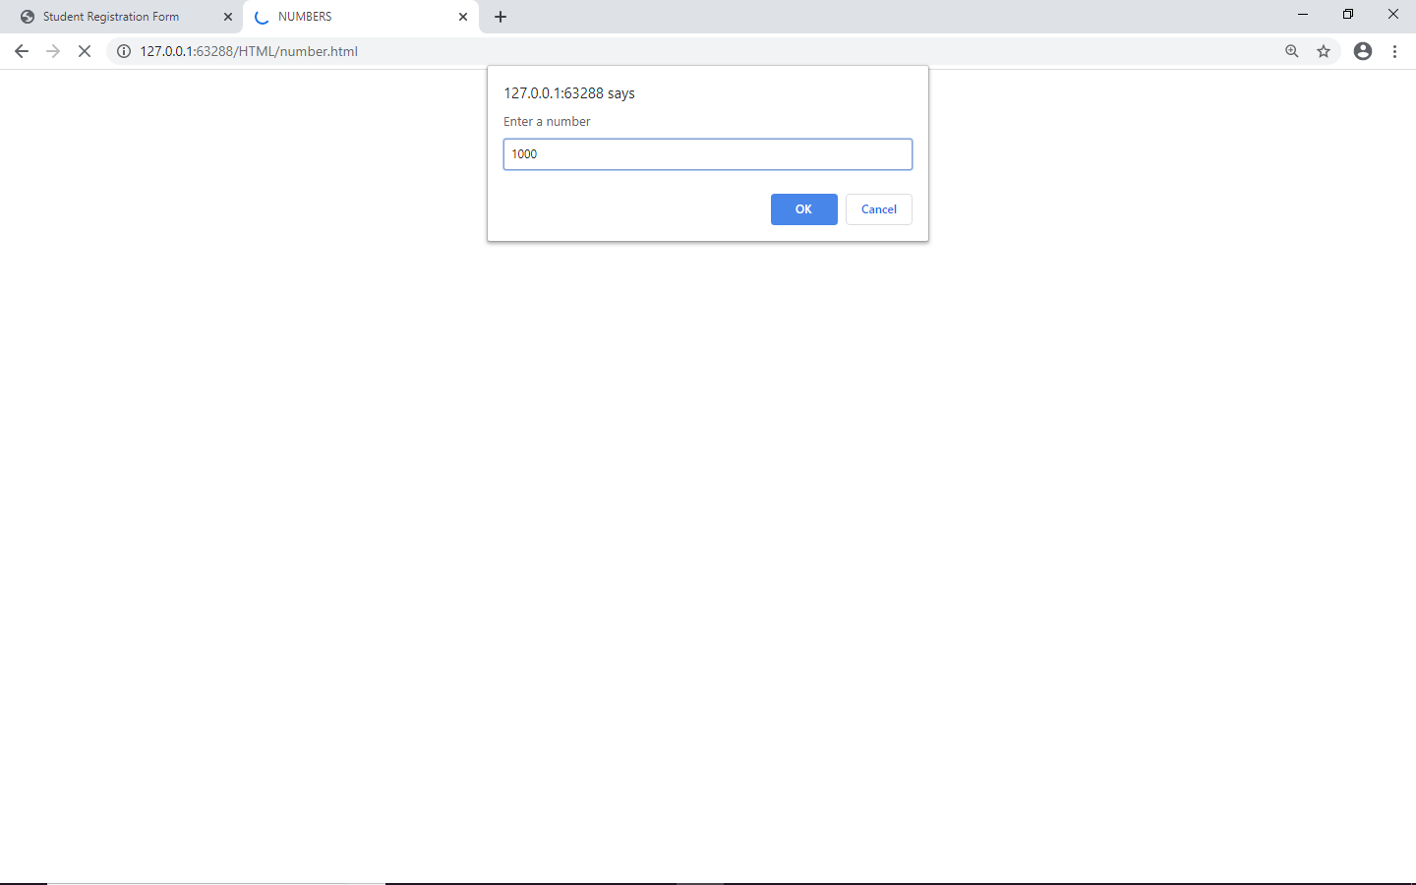

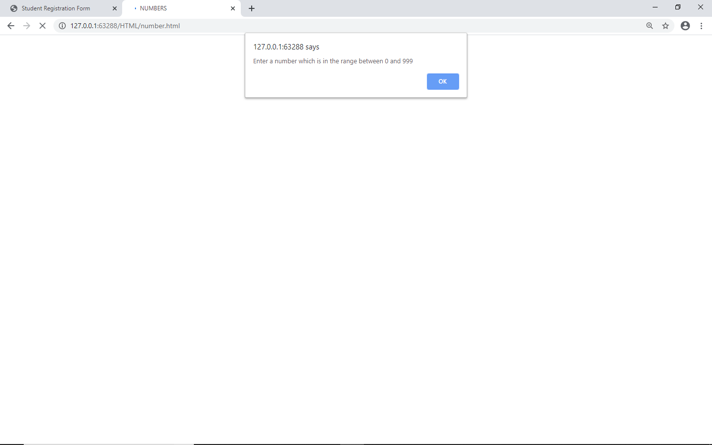

**RESULT:** JavaScript that takes a number from one text field in the range of 0-999 and display it in other text field in words implemented successfully.

**/*4.1 Write a JavaScript to validate the following fields in a registration page created in week 2 a. Name (start with alphabet and followed by alphanumeric and the length should not be less than 6 characters) b. Password (it allows alphanumeric, special symbols and should not be less than 6 characters) c. E-mail (should not contain invalid email addresses)\*\**

<html>

<head><h1 align=center>Welcome to Validation Checking</h1><hr width=50%>

<script language="javascript">

function validation()

{

var x=f.un.value;

varlen=x.length;

var val=x.charCodeAt(0);

var p=f.pw.value;

var c=f.cpw.value;

var a=f.email.value;

var atpos=a.indexOf("@");

var dotpos=a.lastIndexOf(".");

if(len<6 || x=='' || x==null)

{

alert("check your username!! must contain minimum of 6 characters");

}

else if(val<65 || val>90 &&val<97 ||val>122)

{

alert("username must begin with an alphabet");

return false;

}

else if(p=='' || c=='' || p.length<6 || c.length<6 || p!=c)

{

alert("Password and Confirm password should be same and greater than 6 characters!!");

return false;

}

else if(atpos<6 || dotpos<atpos+6 || dotpos+2>=a.length)

{

alert("Not a valid email id");

return false;

}

else

alert("Congratulations!!you have submitted successfully");

}

</script>

</head>

<body>

<table align=center border=1>

<form name="f" action="success.html" onsubmit="return validation();" method="post">

<tr><td>User Name:</td>

<td><input type="text" name="un"/></td></tr>

<tr><td>Password:</td>

<td><input type="password" name="pw"/></td></tr>

<tr><td>Confirm Password:</td>

<td><input type="password" name="cpw"/></td></tr>

<tr><td>E-Mail ID:</td>

<td><input type="text" name="email"/></td></tr>

<tr><td></td>

<td><input type="submit" value="Submit"/></td></tr>

</form>

</table>

</body>

</html>

**OUTPUT:**

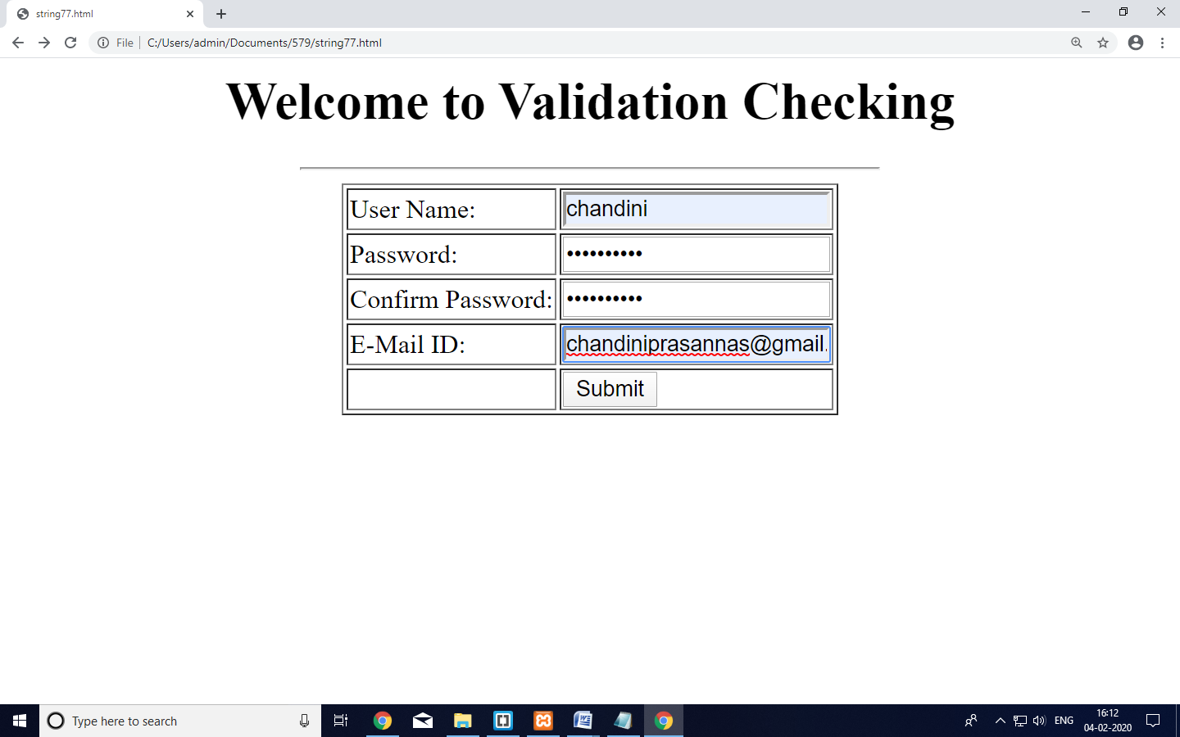

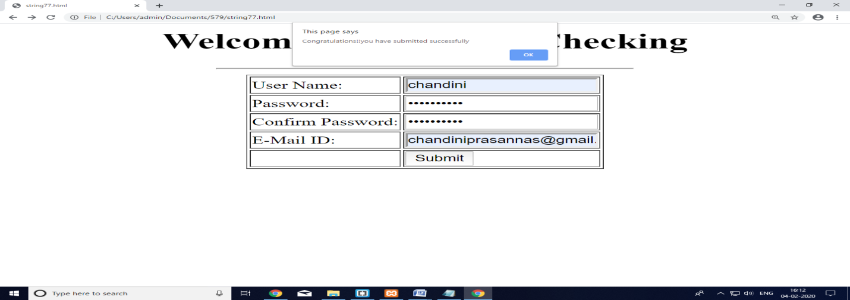

**4.2. Write an XML file which will display the Book information which includes the following:**

**1) Title of the book**

**2) Author Name**

**3) ISBN number**

**4) Publisher name**

**5) Edition**

**6) Price**

**Write a Document Type Definition (DTD) to validate the above XML file.**

**DTD FILE:**

<!ELEMENT BOOK-Info(book)*>

<!ELEMENT book(title,author,ISBN,pub,edition,price)>

<!ELEMENT title(#PCDATA)>

<!ELEMENT author(#PCDATA)>

<!ELEMENT ISBN(#PCDATA)>

<!ELEMENT pub(#PCDATA)>

<!ELEMENT edition(#PCDATA)>

<!ELEMENT price(#PCDATA)>

**XML FILE:**

<?xml version="1.0"?>

<!DOCTYPE BOOK-Info SYSTEM "book.dtd">

<Book-Info>

<book>

<title>WT</title>

<author>Nalini</author>

<ISBN>1233</ISBN>

<pub>sun</pub>

<edition>1</edition>

<price>$50</price>

</book>

<book>

<title>DWDM</title>

<author>Hemalatha</author>

<ISBN>1243</ISBN>

<pub>sun</pub>

<edition>4</edition>

<price>$40</price>

</book>

</Book-Info>

**OUTPUT:**

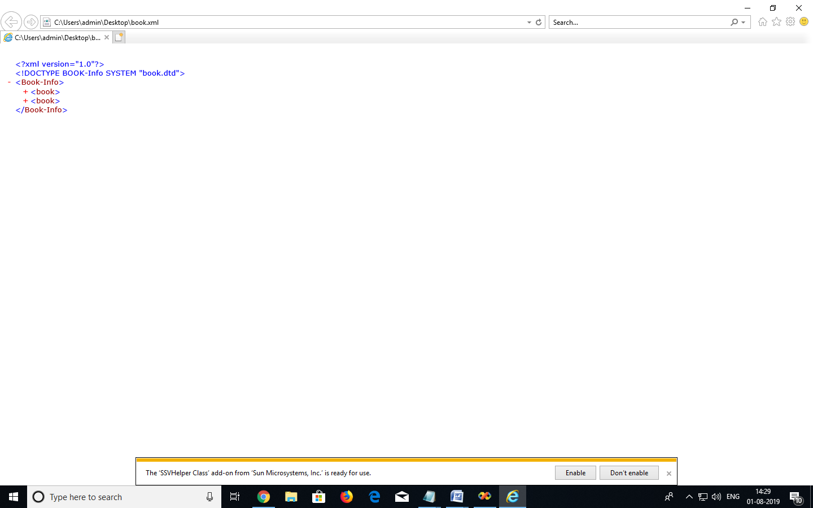

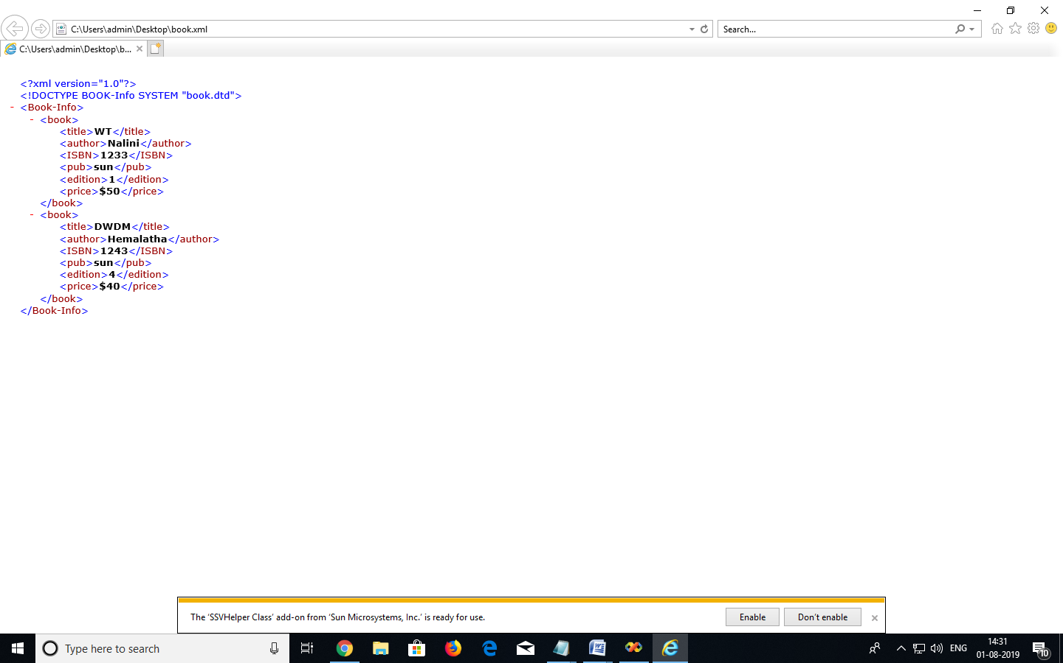

**\*5.1)PHP script to get the first and last day of a month from a specified date*/**

<html>

<body>

<?php

$dt="2014-07-22";

echo 'first day:'.date("Y-m-01",strtotime($dt)).'-last day:'.date("Y-m-t",strtotime($dt));

?>

</body>

</html>

**OUTPUT:**

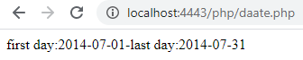

**5.2) Write a PHP script to calculate and display average temperature, five lowest and highest temperatures for the following recorded temperatures. Recorded temperatures : 78, 60, 62, 68, 71, 68, 73, 85, 66, 64, 76, 63, 75, 76, 73, 68, 62, 73, 72, 65, 74, 62, 62, 65, 64, 68, 73, 75, 79, 73.**

**PROGRAM:**

<?php

$month_temp="78,60,62,68,71,68,73,85,66,64,76,63,81,76,73,68,72,73,75,65,74,63,67,65,64,68,73,75,79,73";

$temp_array=explode(',',$month_temp);

$tot_temp=0;

$temp_array_length=count($temp_array);

foreach($temp_array as $temp)

{

$tot_temp+=$temp;

}

$avg_high_temp=$tot_temp/$temp_array_length;

echo "Average Temperature is:".$avg_high_temp."<br>";

sort($temp_array);

echo "List of five lowest temperatures:";

for($i=0;$i<5;$i++)

{

echo $temp_array[$i].",";

}

echo "List of five highest temperatures:";

for($i=($temp_array_length-5);$i<($temp_array_length);$i++)

{

echo $temp_array[$i].",";

}?>

**OUTPUT:**

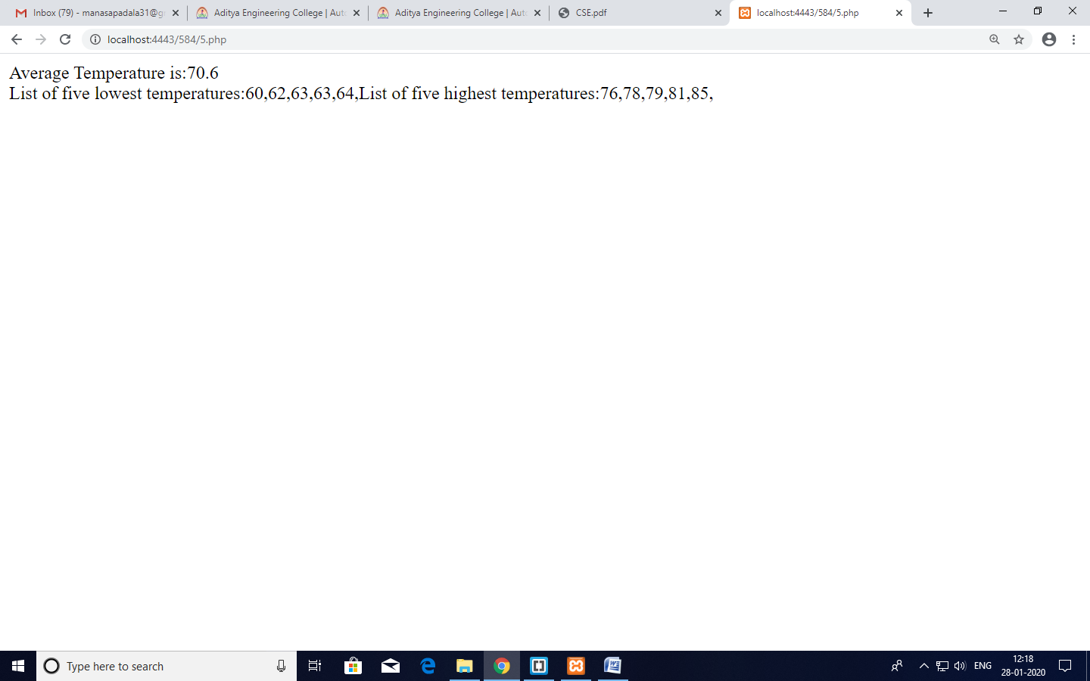

**RESULT:** PHP script and display average temperature and list of lowest and highest temperatures are calculated successfully.

**\*5.3: ) Write a PHP script using nested for loop that creates a chess board.*/**

<html>

<head>

<title></title>

<meta http-equiv="Content-Type" content="text/html; charset=UTF-8">

</head>

<body>

<h3>Chess Board </h3>

<table width="270px" cellspacing="0px" cellpadding="0px" border="1px">

<!-- cell 270px wide (8 columns x 60px) -->

<?php

for($row=1;$row<=8;$row++)

{

echo "<tr>";

for($col=1;$col<=8;$col++)

{

$total=$row+$col;

if($total%2==0)

{

echo "<td height=30px width=30px bgcolor=white></td>";

}

else

{

echo "<td height=30px width=30px bgcolor=black></td>";

}

}

echo "</tr>";

}

?>

</table>

</body>

</html>

**OUTPUT:**

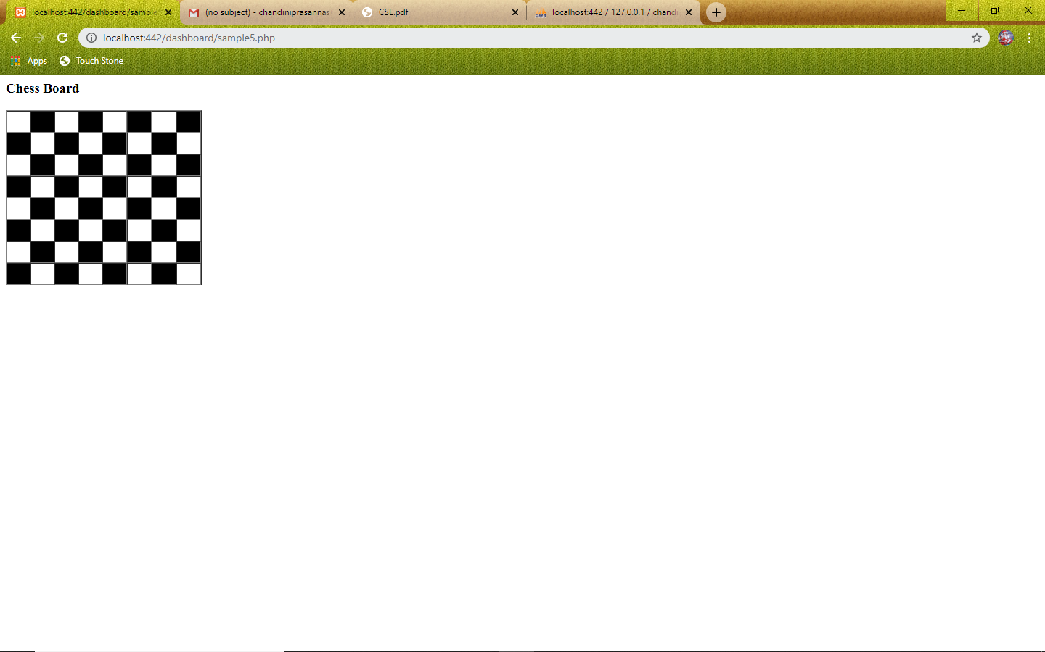

**RESULT:** PHP script using nested for loop that creates a chess board implemented successfully.

**\*6.1: PHP script to sort the following associative array.**

**array("Sophia"=>"31","Jacob"=>"41","William"=>"39","Ramesh"=>"40")*/.**

<html>

<body>

<?php

$names=array("Sophia"=>"31","Jacob"=>"41","William"=>"39","Ramesh"=>"40");

echo "Descending order according to values";

echo"<br>";

arsort($names);

foreach($names as $key=>$val)

{

echo $key."=>".$val;

echo "<br>";

}

echo "Descending order according to keys";

echo"<br>";

krsort($names);

foreach($names as $key=>$val)

{

echo $key."=>".$val;

echo "<br>";

}

echo "Ascending order according to values";

echo"<br>";

asort($names);

foreach($names as $key=>$val)

{

echo $key."=>".$val;

echo "<br>";

}

echo "Ascending order according to keys";

echo"<br>";

ksort($names);

foreach($names as $key=>$val)

{

echo $key."=>".$val;

echo "<br>";

}

?>

</body>

</html>

**Saving and Execution of PHP Program.**

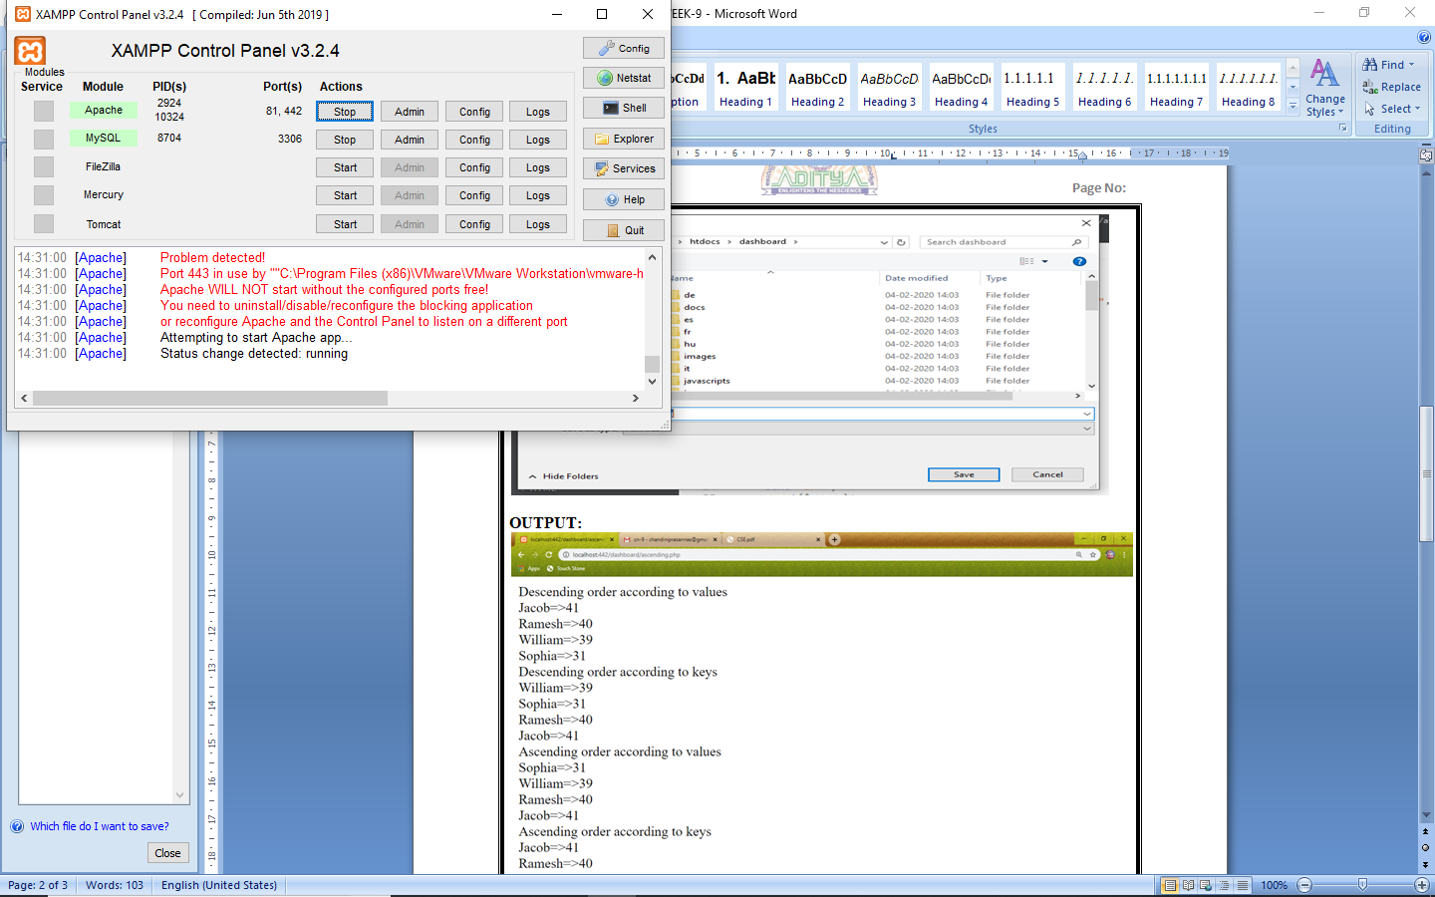

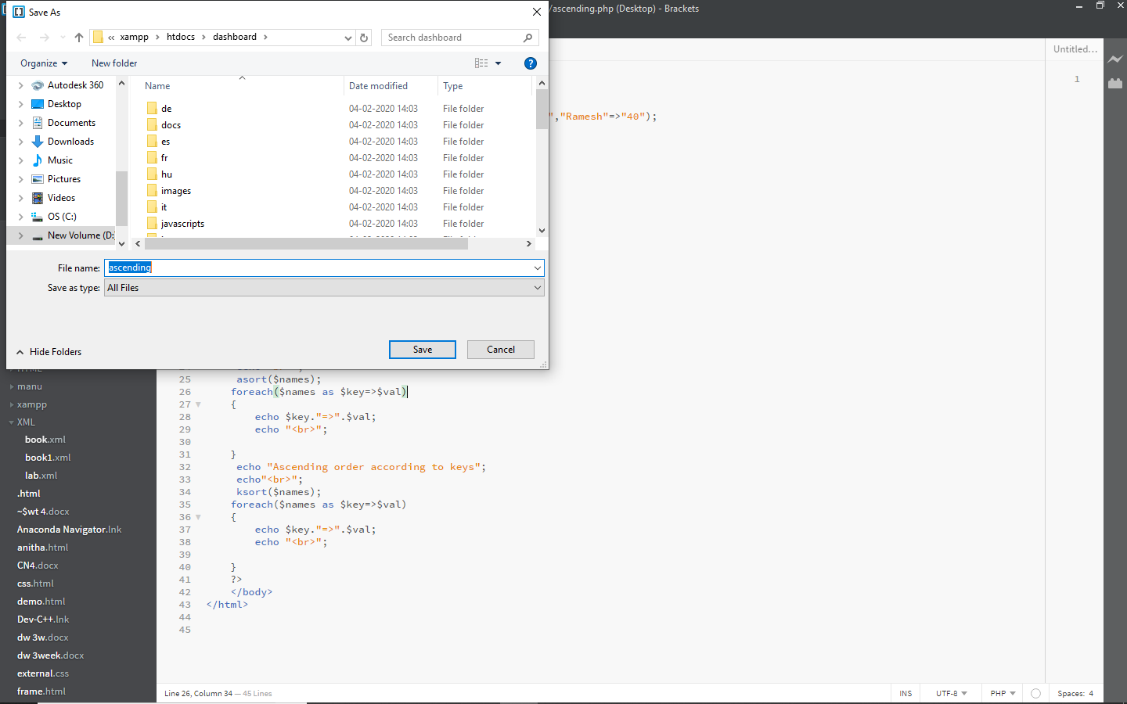

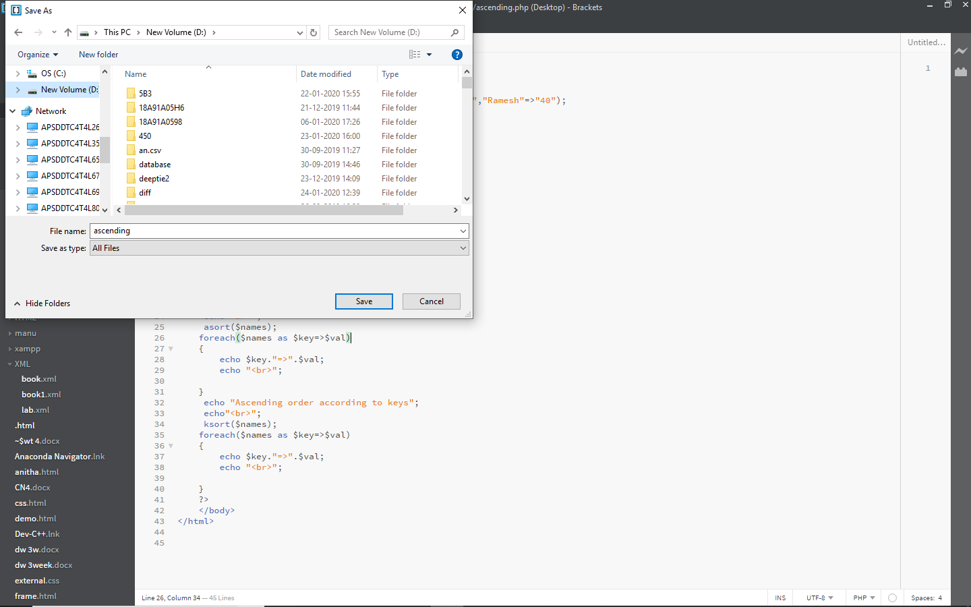

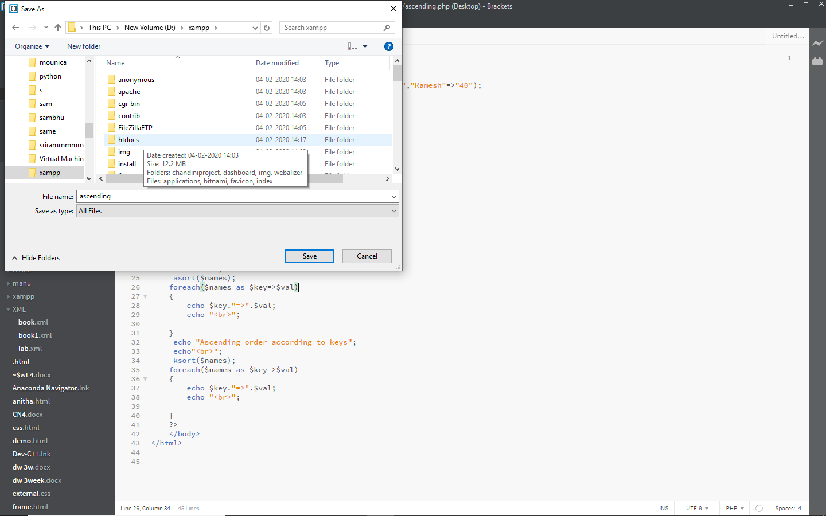

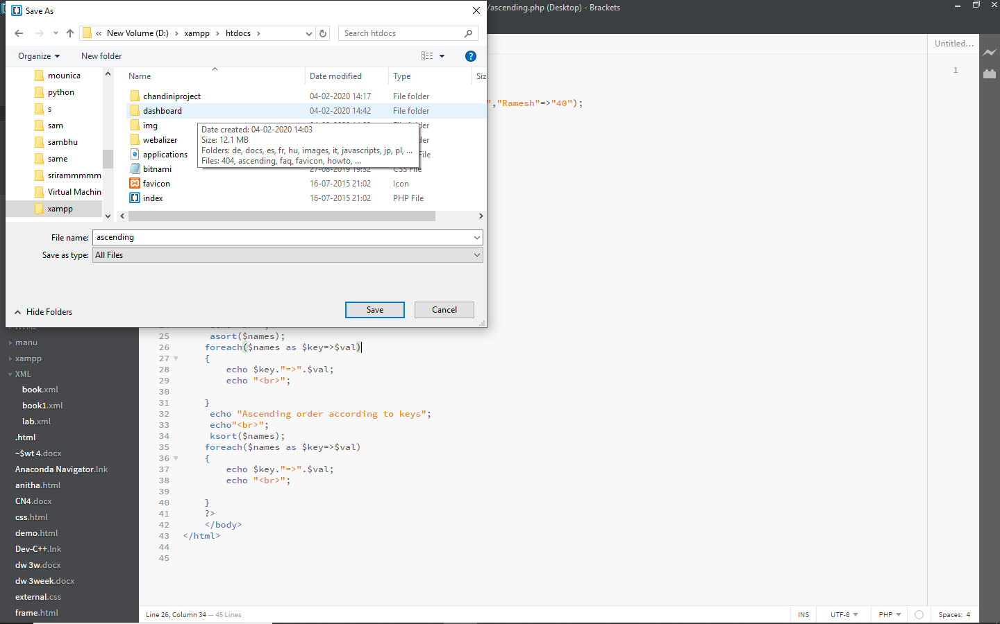

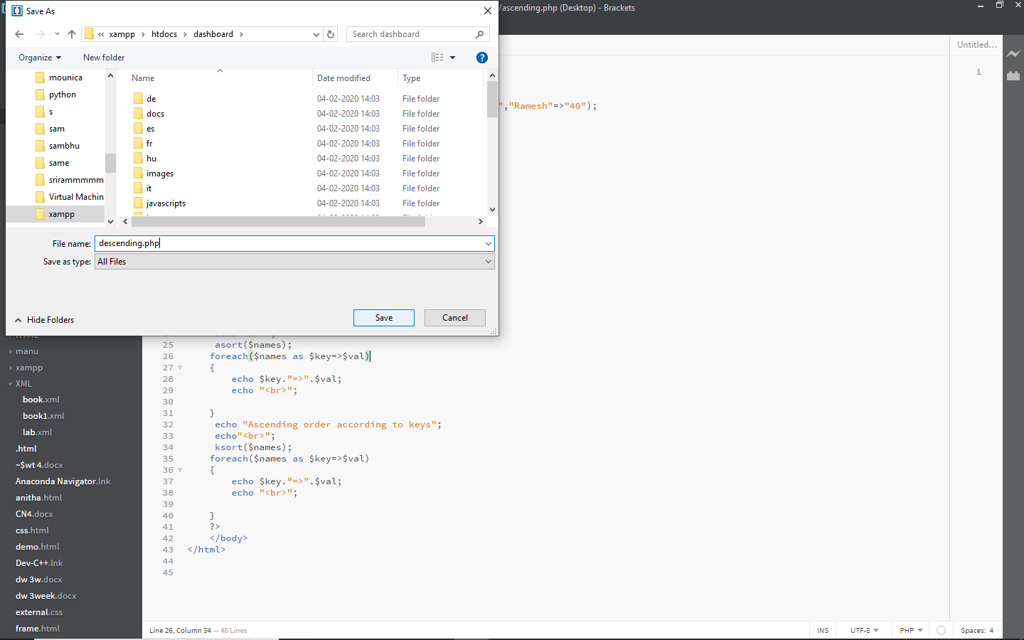

**OUTPUT:**

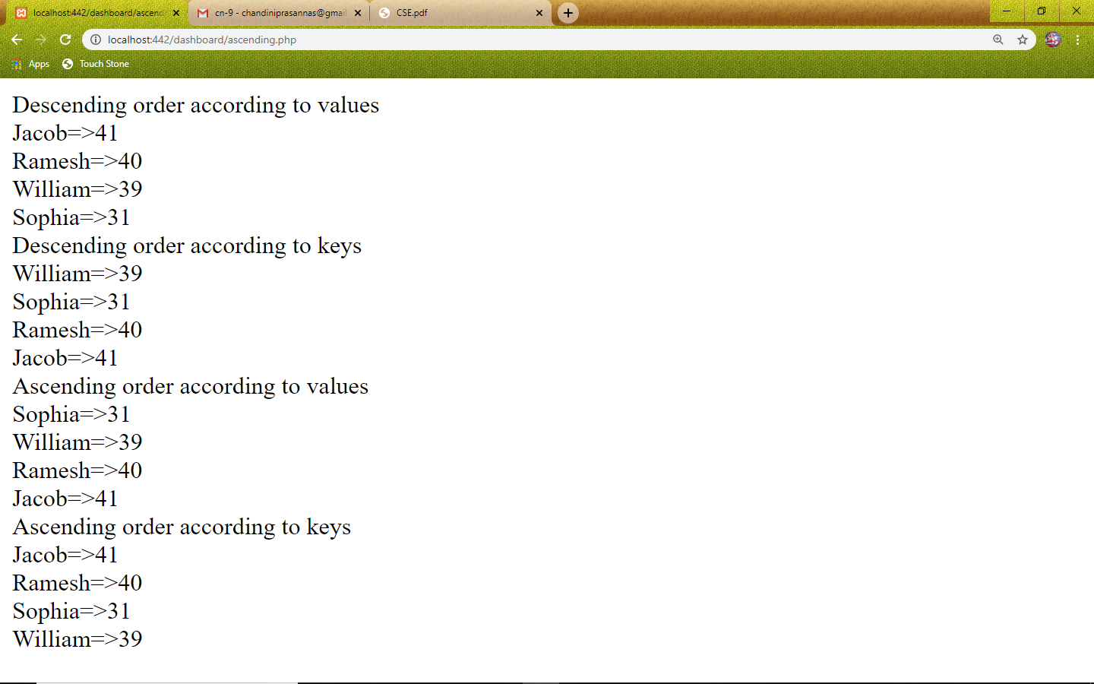

**RESULT:** PHP script to sort the following associative array.

array("Sophia"=>"31","Jacob"=>"41","William"=>"39","Ramesh"=>"40) is sorted successfully.

**\*6.2: PHP script to generate simple random password [do not use rand() function] from a given string*/.**

<html>

<body>

<?php

function password_rand_gen($pwd)

{

$data="1234567890ABCDEFGHIJKLMNOPQRSTUVWXYZZabcdefghijklmnopqrstuvwxyz";

return(substr(str_shuffle($data),7,$pwd));

}

echo password_rand_gen(10);

?>

</body>

</html>

**OUTPUT:**

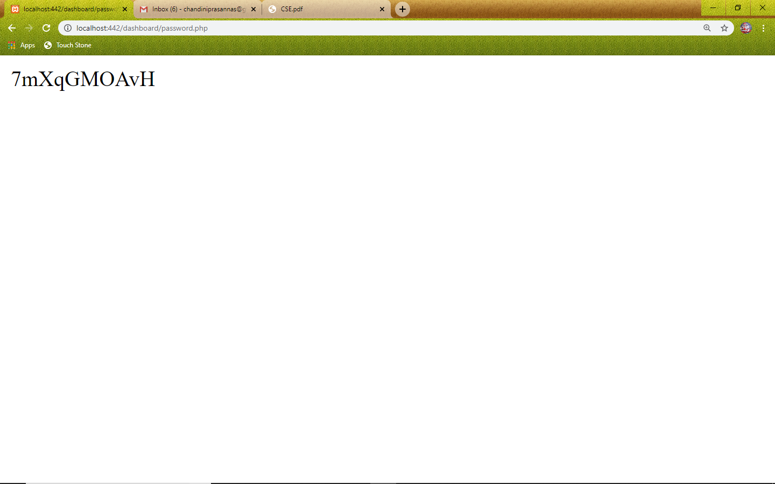

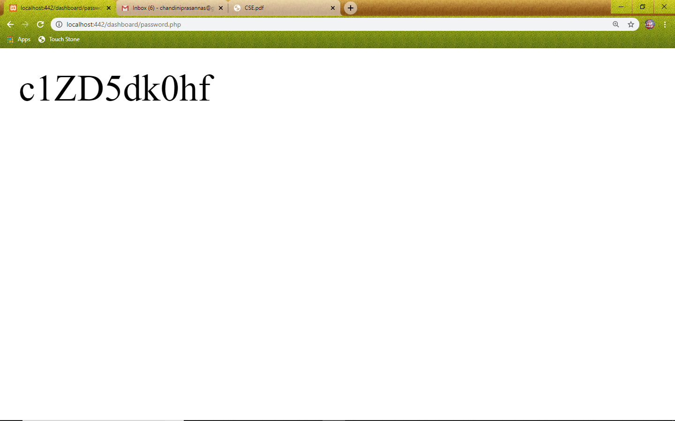

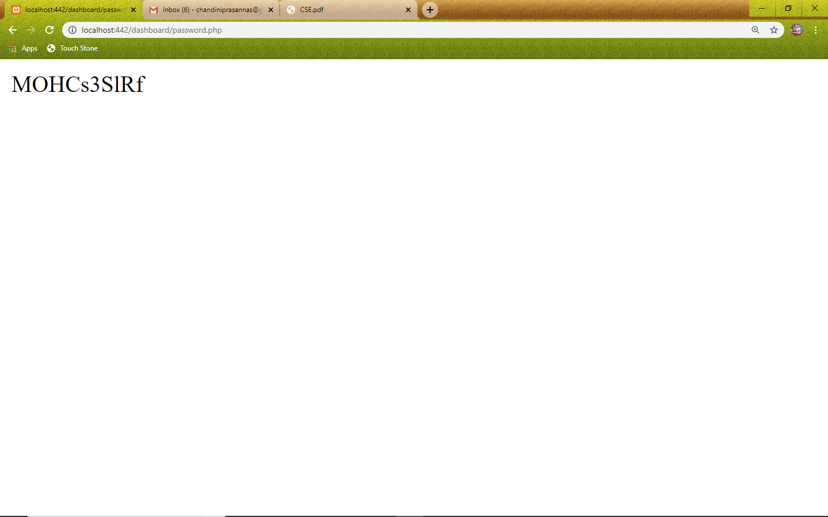

**RESULT:** PHP script to generate simple random password [do not use rand() function] from a given string is generated successfully.

**6.3)/* Install a database (MySQL). Create a table which should contain at least the following fields: name, password, email-id, phone number (these should hold the data from the registration form).*/**

**PHP CODE:**

<?php

$conn = mysqli_connect("localhost","root","","chandini");

if($conn)

echo "Connected to database!!!"; else

echo "Failed to Connect:".mysqli_error();

if(isset($_REQUEST['uname']))

{

$uname=$_REQUEST['uname'];

$pass=$_REQUEST['pass'];

$email=$_REQUEST['email'];

$phno=(float)$_REQUEST['phone'];

$query = "INSERT INTO employee VALUES('$uname','$pass','$email','$phno')"; $result=mysqli_query($conn,$query);

if($result)

echo "Inserted Successfully";

}

?>

**HTML CODE:**

<html>

<head>

<title> User Registration Page</title>

<script language="javascript">

function validate()

{

var nam = document.f1.uname.value; if(nam=="")

{

alert("Please enter name"); document.f1.uname.focus;

return false;

}

var pwd = document.f1.pass.value; if(pwd=="")

{

alert("Please enter Password"); document.f1.pass.focus;

return false;

}

var email = document.f1.email.value; if(email=="")

{

alert("Please enter youe email"); document.f1.email.focus;

return false;

}

var phno = document.f1.phone.value; len=phno.length

if(phno=="" || len != 10)

{

alert("Please enter phno or should be strictly 10 digits"); document.f1.phone.focus;

return false;

}

}

</script>

</head>

<body>

<br/><br/><br/>

<center>

<form name="f1" action="chandu.php" method="post" onsubmit="javascript:return validate()">

<table border="3" cellpadding="0" cellspacing="0">

<tr>

<td>

<table cellspacing="10">

<tr>

<td colspan="2" align="center"><h2><u>User Registration Form</u></h2></td>

</tr>

<tr>

<td>User Name</td>

<td><input type="text" name="uname" size="50"></td>

</tr>

<tr>

<td> Password</td>

<td><input type="password" name="pass" size="50"></td>

</tr>

<tr>

<td>E-mail</td>

<td><input type="text" name="email" size="50"></td>

</tr>

<tr>

<td>Phone</td>

<td><input type="text" name="phone" size="15"></td>

</tr>

<tr>

<td colspan="2" align="center"><input type="submit" value="submit"></td>

</tr>

</table>

</td>

</tr>

</table>

</form>

</center>

</body>

</html>

**OUTPUT:**

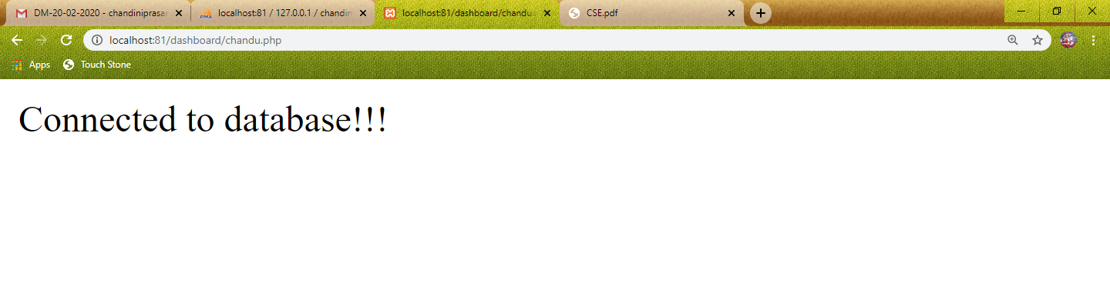

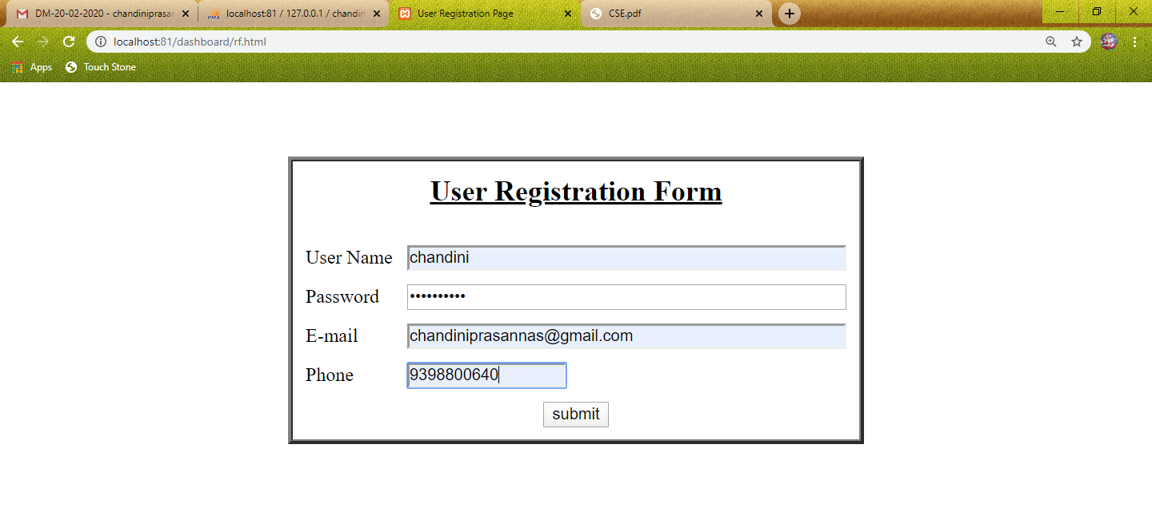

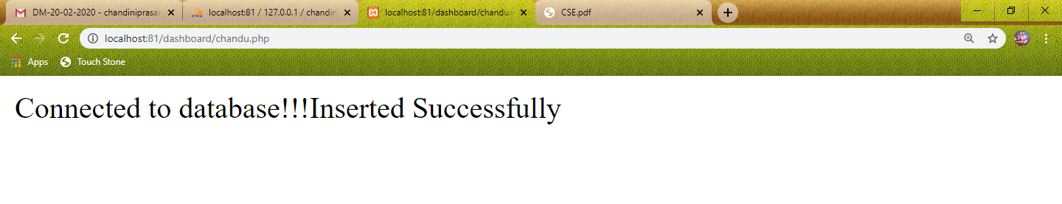

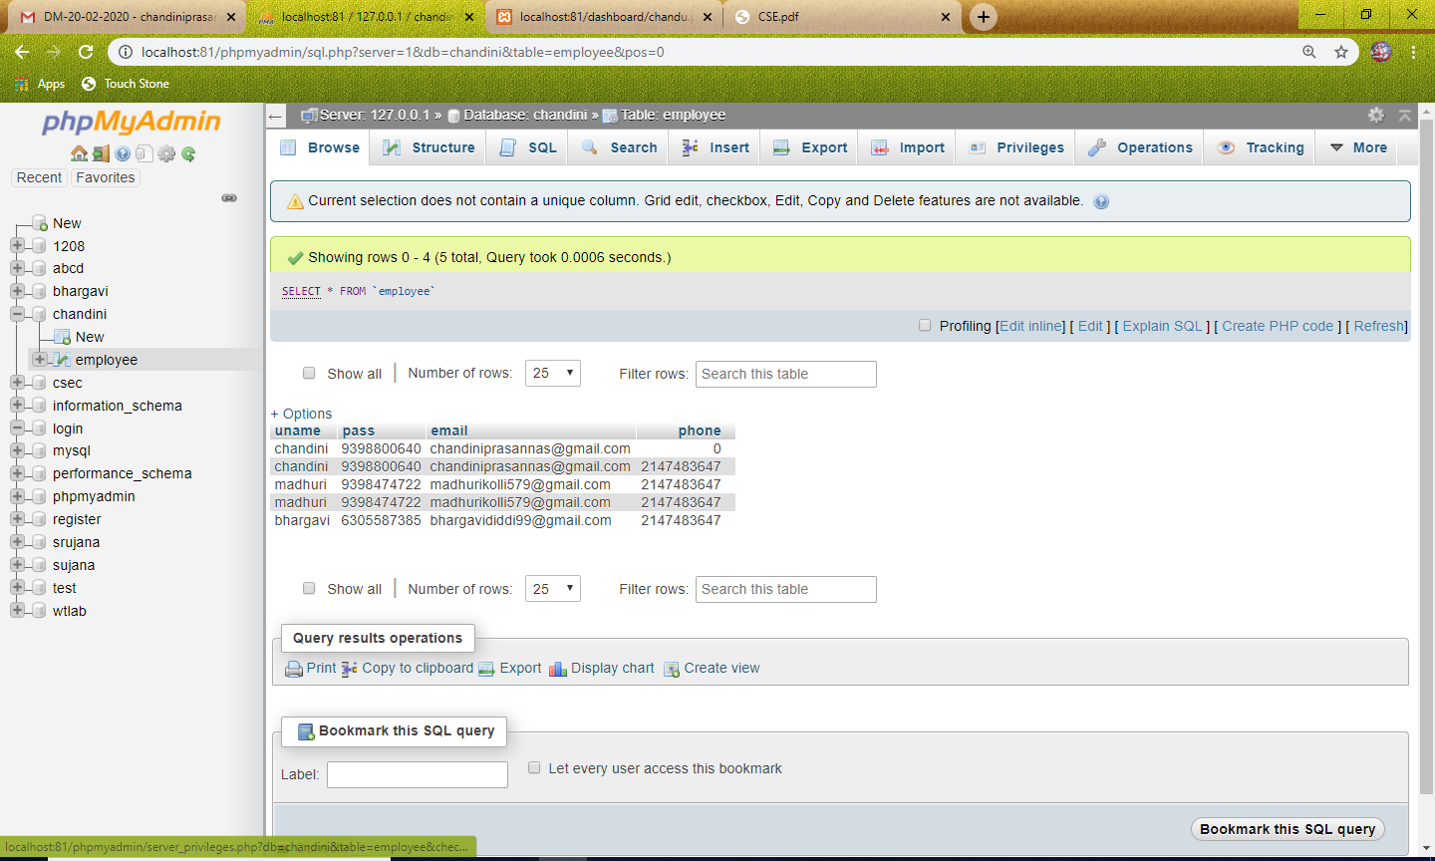

**RESULT:**MYSQL Database is created and data is inserted successfully.

**/*7.1) Write a PHP program to connect to the database and extract data from the tables and display them.*/**

<?php

$conn = mysqli_connect("localhost","root","","chandini");

if($conn)

echo "Connected to database!!!"; else

echo "Failed to Connect:".mysqli_error();

$result = mysqli_query($conn,"select *from employee");

?>

<html>

<body>

<br/><br/><br/>

<p align="right"></p>

<center>

<font face="verdana" size="4">

<table border="1" cellpadding="0" cellspacing="0">

<tr>

<th colspan="4" align="center">User List</th>

</tr>

<tr>

<th>S.NO.</th>

<th>Email</th>

<th>User Name</th>

<th>Phone</th>

</tr>

<?php $num=1;

while($row = mysqli_fetch_array($result))

{?>

<tr>

<td><?php echo $num++; ?> </td>

<td><?php echo $row['email']; ?> </td>

<td><?php echo $row['uname']; ?> </td>

<td><?php echo $row['phone']; ?> </td>

</tr>

<?php }?>

</table>

</font>

</center>

</body>

</html>

<?php

?>

**OUTPUT:**

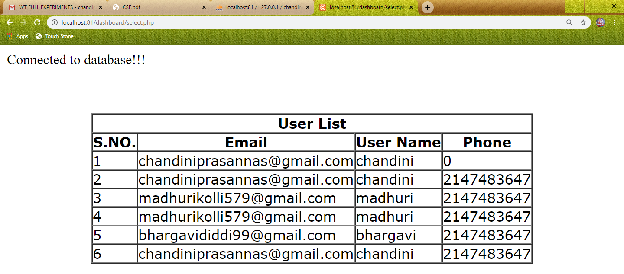

**RESULT:** PHP program to connect to the database and extracted data from the tables and displayed successfully.

**8.1) Write a PHP code to connect to the database and update the password using username**

**Update.html:**

<html>

<body>

<form method="post" action="updation.php" name="rf1">

<table align="center">

<caption>UPDATION FORM</caption>

<tr><td></td><td></td></tr>

<tr>

<td>Employee ID: &nbsp </td>

<td><input type="text" name="eid" size="20"/></td>

</tr>

<tr>

<td>Enter the New PASSWORD:&nbsp </td>

<td><input type="password" name="pwd" size="20"/></td>

</tr>

</table>

<table align="center">

<tr>

<td align="right"><input type="submit" value="UPDATE" name="upd"/></td>

&nbsp;&nbsp;<td></td><td></td>

<td align="center"><input type="reset" value="CLEAR"/></td>

</tr>

</table>

</form>

</body>

</html>

**Updation.php:**

<html>

<body>

<?php

$host = "localhost";

$user = "root";

$pwd = "";

$db = "employee";

$db_found = mysqli_connect($host,$user,$pwd,$db);

if(isset($_POST['upd']))

{

if($db_found)

{

$id=$_POST['eid'];

$newpassword=$_POST['pwd'];

$in="update emp set password='$newpassword' where eid='$id'";

$result=mysqli_query($db_found,$in);

if($result)

echo "updated successfully";

else

echo "not updated";

}

}

?>

</body>

</html>

**OUTPUT:**

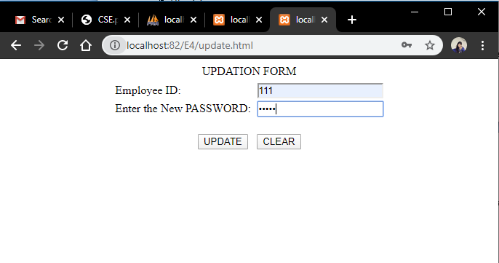

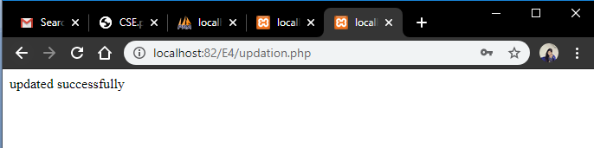

**Before updation:**

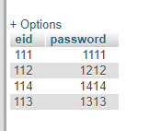

**After updation:**

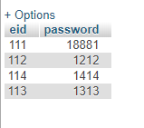

**RESULT:** Updation operation on data base is performed successfully.

**8.2) Write a PHP code to connect to the database and perform deletion operation in the table using username.**

**Deletion.html:**

<html>

<body>

<p align="right"><a href="index.html">HOME</a></p>

<form method="post" action="demo.php" name="rf1">

<table align="center">

<caption><b><font color="red">DELETION FORM</font></b></caption>

<tr><td></td><td></td></tr>

<tr>

<td>Employee ID: &nbsp </td>

<td><input type="text" name="eid" size="20"/></td>

</tr>

</table>

<table align="center">

<tr>

<td align="right"><input type="submit" value="DELETE" name="del"/></td><td></td>

<td align="right"><input type="submit" value="DELETE ALL" name="del1"/></td>

&nbsp;&nbsp;<td></td>

<td></td><td align="center"><input type="reset" value="CLEAR"/></td>

</tr>

</table>

</form>

</body>

</html>

**Demo.php:**

<html>

<body>

<?php

$host = "localhost";

$user = "root";

$pwd = "";

$db = "employee";

$db_found = mysqli_connect($host,$user,$pwd,$db);

if($db_found)

{

if(isset($_POST['del']))

{

$id=$_POST['eid'];

$sql="delete from emp where eid='$id'";

$result=mysqli_query($db_found,$sql);

if($result)

echo "Deleted successfully";

else

echo "Record not Deleted";

}

else if(isset($_POST['del1']))

{

$sql="delete from emp";

$result=mysqli_query($db_found,$sql);

if($result)

echo "Deleted successfully";

else

echo "Record not Deleted";

}

}

else

echo "Database Connection failure";

?>

</body>

</html>

**OUTPUT:**

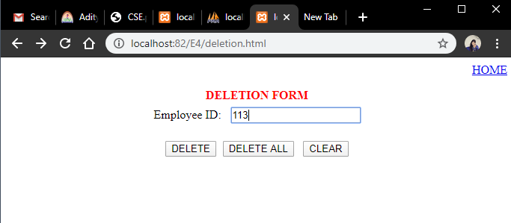

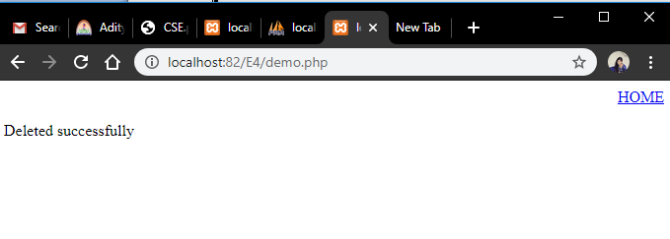

**Before deletion:**

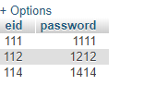

**After deletion:**

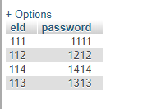

**RESULT:** Deletion operation on data base is performed successfully.

**/*9.1) Write a program to store 5 employee salaries using associative arrays in Perl, where employee name is a key and salary being used as a value and find the total salary and average salary paid by the company to the employees and display the same.*/**

%data = ('Chandini' => 45000, 'Madhuri' => 30000, 'Bhargavi' => 40000, 'Manasa'=>20000, 'Sandeepthi' => 28000);

print "Chandini Salary is: = $data{'Chandini'}\n";

print "Madhuri Salary is: = $data{'Madhuri'}\n";

print "Bhargavi Salary is: = $data{'Bhargavi'}\n";

print "Manasa Salary is: = $data{'Manasa'}\n";

print "Sandeepthi Salary is: = $data{'Sandeepthi'}\n";

$tot=$data{'Chandini'}+$data{'Madhuri'}+$data{'Bhargavi'}+$data{'Manasa'}+$data{'Sandeepthi'};

$avg=$tot/5;

print "Total Salary Paid to the employees is: ";

print $tot,"\n";

print "Average Salary Paid to the employees is: ";

print $avg;

**OUTPUT:**

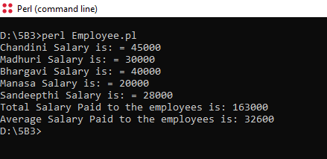

**/*9.2) Write Perl program takes set names along the command line and prints whether they are regular files or special files*/**

$len = @ARGV;

for ($i=0;$i<$len;$i++)

{

if(-e $ARGV[$i])

{

if(-T $ARGV[$i])

{

print "$ARGV[$i] is a text file\n";

}

else

{

print "$ARGV[$i] is a special file\n";

}}

else

{

print "$ARGV[$i] does not exists";

}}

**OUTPUT:**

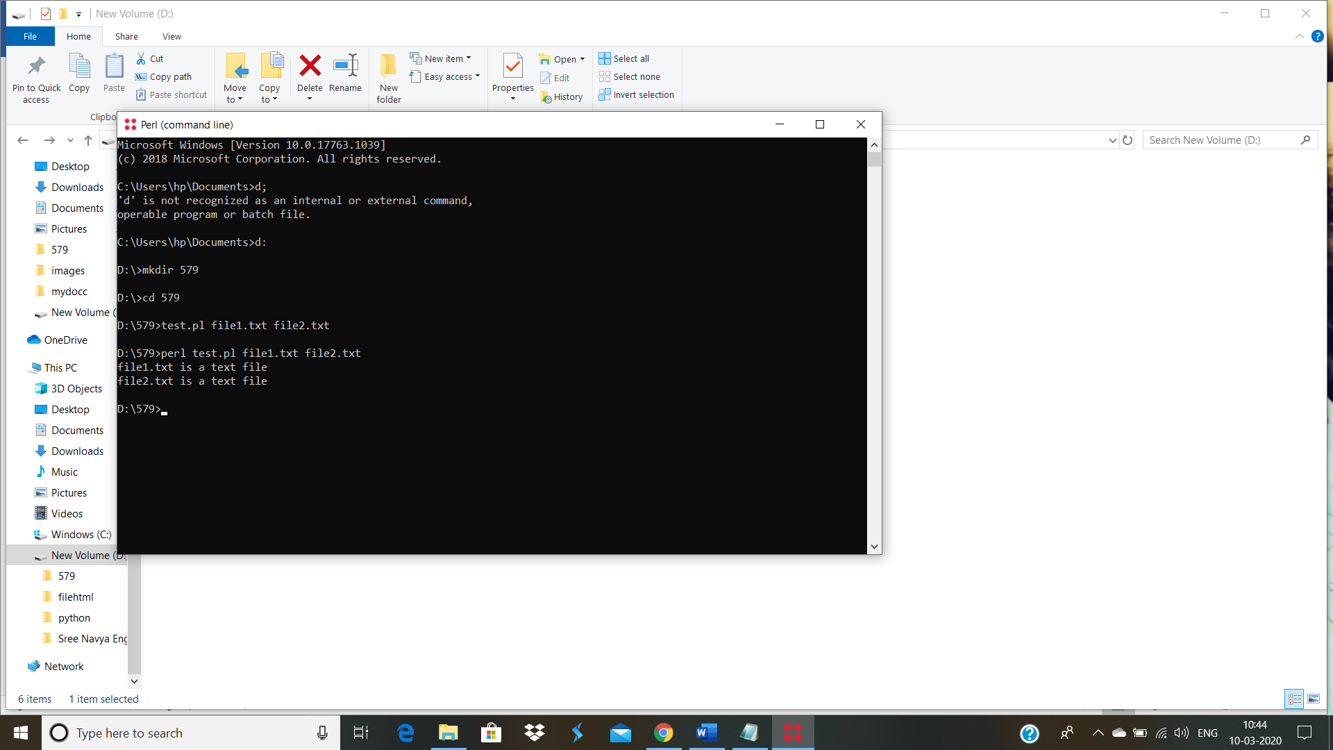

**/*9.3.1) Program to define a subroutine*/**

# Function definition

sub Hello {

print "Hello, World!\n";

}

# Function call

Hello();

**OUTPUT:**

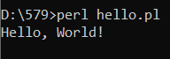

**/* 9.3.2) Passing Lists and Hashes to a subroutine*/**

sub Average{

$n=scalar(@_);

$sum=0;

foreach $item (@_) {

$sum += $item;

}

$average= $sum/ $n;

print "average for the given numbers: $average\n";

}

Average(10,15,20);

sub PrintHash {

my (%hash) = @_;

foreach $key (keys%hash){

my $value= $hash{$key};

print "$key : $value\n";

}

}

%hash =('madhu'=> 50000,'bhaghi'=>80000,'chandu'=>60000);

PrintHash(%hash);

**OUTPUT:**

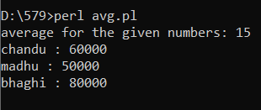

**/*9.3.3) Returning value from a subroutine*/**

sub Average{

$n=scalar(@_);

$sum=0;

foreach $item (@_) {

$sum += $item;

}

$average= $sum/ $n;

return $average;

}

$res=Average(10,15,20,43,55);

print "The average is:",$res;

**OUTPUT:**

